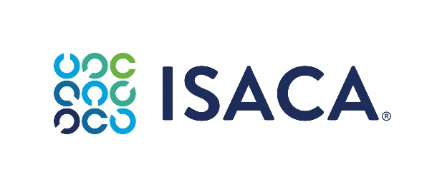

Form 3 –Appeal Form
To be submitted at ethics@isaca.org

Appeal Form
Confidential

Please read the ISACA Code of Professional Ethics - Member Ethics Violation Review Policy (“Policy”) before completing and submitting this form.

Date of Submission:
Subject – individual that is the subject of a Panel Determination that includes a Corrective Action.
Name:
Address:
Phone Number:
Email Address:

ISACA has provided you with the following documents in response to a Review Panel Determination that includes a Corrective Action other than a Warning Letter according to the Policy.
- A copy of the Policy
- The Review Panel Determination
- Link to the Appeal Form for your use
If you decide to submit the Appeal Form upon receipt of the Review Panel Determination, you must do so within 45 calendar days of the receipt of the Review Panel Determination.
An Appeal Form may only be submitted if one or more of the following criteria are met. Please indicate with an “X” below next to the one or more criteria items you are using as the basis of your appeal.
Procedural Error: ISACA did not follow the procedures outlined in the Policy. Deviation from the timelines outlined in the Section: Report of Alleged Violation Timeline or elsewhere in the Policy does not meet the criteria for an appeal.
Factual Error: The Subject can show that the facts outlined in the Investigation Summary are not true, and this evidence was not available at the time of the Review Panel’s original decision.
Severity of Corrective Action: The Corrective Action was too severe or not congruent with the violation, or extenuating circumstances exist.

Provide a statement of what you consider to be the essential facts that support the one or more criteria you have indicated above. If you have previously submitted a Response Form, you do not need to repeat information you have already provided.

Do you agree with any of the allegations included in the Review Panel Determination? If so, please state and explain.

List all persons that you believe have knowledge of the matters asserted in your statements above along with their contact information.

Are you attaching documents as evidence to support your response? If so, please describe what you are attaching and how the documents support your response.

Please identify any matters filed with state licensure or regulatory panels, courts or other judicial forums, professional organizations, and employers that relate to the issues raised in the Review Panel Determination.
Subject is under a continuing obligation to advise ISACA of any additional ethics responses that may be filed with other bodies subsequent to the time that you submit this Appeal Form, or that were previously filed but that you did not have knowledge at the time this Response was submitted.

Please certify that the factual allegations made in this Response to the Investigation Summary are true and accurate to the best of your knowledge and are made in good faith.

Name:
Date:

